WhiteBox Testing Report

Rory O’Day 011592775

**Development Environment**: Eclipse IDE for RCP and RAP Developers

**Testing Framework:** Mockito 3.12.4 and JUnit 5.7.2

**Test Cases:**

OperandCountCheck:

* Correct Default Tokens
* Correct Acceptable Tokens
* Correct Required Tokens
* Single Operand Token
* Unique Operands
* Multiple Unique Operands
* No Operands
* FinishTree error message

OperatorCountCheck:

* Correct Default Tokens
* Correct Acceptable Tokens
* Correct Required Tokens
* Unique operands
* Nested unique operands
* Nested operands with unique operators
* FinishTree error message

ExpressionCountCheck:

* Correct Default Tokens
* Correct Acceptable Tokens
* Correct Required Tokens
* Single expression
* Multiple expressions
* No expressions
* FinishTree error message

LoopCountCheck:

* Correct Default Tokens
* Correct Acceptable Tokens
* Correct Required Tokens
* For Loops
* While Loops
* Do While Loops
* Variation of all types of loops
* No Loops
* FinishTree error message

CommentCountCheck:

* Correct Acceptable Tokens
* Correct Default Token
* Correct Required Tokens
* Line Comments
* Block Comments
* Variation of line and block comments
* No Comments
* FinishTree error message

HalsteadEffortCheck:

* Correct Default Tokens
* Correct Acceptable Tokens
* Correct Required Tokens
* Mocked values of volume and difficulty
* Incorrect Token
* No Token
* FinishTree error message

HalsteadLengthCheck:

* Correct Default Tokens
* Correct Acceptable Tokens
* Correct Required Tokens
* Single operand and multiple operators
* Multiple operands and single operator
* Multiple operands and operators
* No operands and operators
* FinishTree error message

HalsteadVocabularyCheck:

* Correct Default Tokens
* Correct Acceptable Tokens
* Correct Required Tokens
* Multiple operands and operators
* No unique operands and operators
* FinishTree error message

HalsteadVolumeCheck:

* Correct Default Tokens
* Correct Acceptable Tokens
* Correct Required Tokens
* Known Length and Volume Values
* Zero Length and Volume Values
* FinishTree error message

**Coverage:**

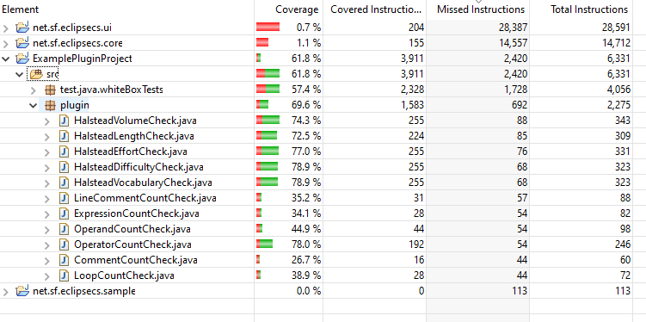

Note: I know this chart is not correct, the actual coverage should be much higher. Checking coverage was not working in a way that I expect, anything inside the Try block would count as not covered. Visit Token would count as not covered even though I explicitly called the function in each test.